Glycine from Space and in Solution: A Happy Marriage between Amino Acid and Water
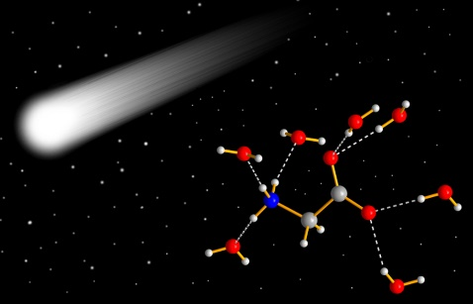

As the building blocks of proteins, amino acids are key ingredient of life. Glycine, as the simplest form of amino acids, together with water, are the most ‘wanted’ molecules when scientists search for the evidence of life in other Earth-like planets, and the origin of life on Earth. If they do exist in the outer space, in which form are they stacked? A recent study suggests that a possible answer, glycine and water will fall in love with each other and form a hydrate.
As one of the most abundant amino acids in nature, glycine is a fascinating molecule for the scientists. "This (glycine) fun, cute, small, famous biomolecule fascinates me with respect to its structure diversity. Whenever you have some new ideas or tools, you want to test them on glycine first." said by Dr. Chunhua (Tony) Hu, a senior crystallographer at the Department of Chemistry of New York University.
In 2001, a group of researchers at the University of Wisconsin Madison observed a new phase when they quenched the aqueous glycine solution in liquid nitrogen and kept the solid at 208 K. The new phase was called “X-phase” by a research group at the Novosibirsk State University in Russia, when they revisited this unknown phase.
Puzzled by the X-phase, Dr. Hu attempted to solve its structure by preparing the sample with a method called flash cooling. Having tried numerous recipes, he figured out the optimal conditions to reproduce the X-phase. The same sample was then sent to the Advanced Photon Source, Argonne National Laboratory for further X-ray diffraction analysis. The beamline scientist, Dr. Wenqian Xu, examined the sample, and he says, “The diffraction data looks pretty good, and it is sufficient to determine its unit cell parameters. However, we could not to find any appropriate solutions regarding how the molecular arrangement in the unit cell! We need help from theory.”
At the University of Nevada, Las Vegas, Dr. Qiang Zhu, an Assistant Professor at the Department of Physics and Astronomy, is leading a team to develop a novel method for crystal structure prediction, which allows them to find optimal structures and compositions of new compounds. By considering the possibilities suggested by prior XRD analysis, the search immediately yielded a dihydrate model possessing the best agreement with the observed diffraction pattern. Zhu says, “It is quite amazing that such crystal structure search only took a few days even on an ordinary desktop. The crystal structure looks beautiful. It contains one glycine molecule and two water molecules in an asymmetric unit. Each glycine molecule is surrounded by seven water molecules via hydrogen bonds. Glycine molecules are well separated by water. The absence of strong glycine-glycine and water-water interactions make the hydrate rather unique. Such feature has not been found in other amino acids hydrates discovered so far. This is perhaps the only way to make such harmony marriage possible between glycine and water.”
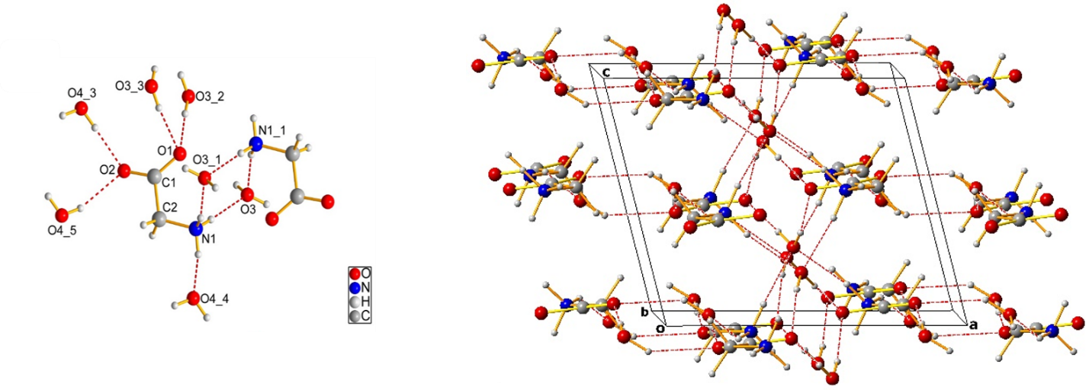
Fig 1. Glycine·7H₂O species and its packing in three dimensional spaces

More interestingly, the establishment of GDH might have greater implication in planetary science. In 2009, the presence of glycine sampled in 2004 from comet Wild 2 by NASA spacecraft Stardust was confirmed. In 2016, glycine was again detected in Comet 67P/Chuyumov-Gerasimenko by Rosetta spacecraft. The comets, popularly described as “dirty snowballs”, are at low temperature with massive ice, providing the right conditions to stabilize GDH. Thus it is likely that glycine could be embedded in the cometary ice and then released together with other volatiles.
"Initially, we just attempted to solve a crystal structure accidentally found in pharmaceutical engineering processes. " says Dr. Zhu. " We didn’t expect it might have greater value in planetary sciences. If the results prove to be useful, why not apply the same approaches to study other life-relevant organic molecules?"
The results of this work, "Structure of Glycine Dihydrate: Its implications to Crystallization of Glycine from Solution and Modification of Glycine in Space" were published on Jan 18, 2017 in Angewandte Chemie (doi: 10.1002/anie.201610977).

